ELEC 2110

Electric Circuit Analysis

Gabriel Emerson

Jake Bryson

October 15, 2019

Section 002

Electrical Measurements: First-Order Transient Circuits

Introduction

Using the NI Elvis Oscilloscope, the student will take measurements of different circuits, and calculate specific components on circuits given. The student will wire up these circuits and then take the measurements on the oscilloscope.

Exercise 1

Open the function generator on the NI Elvis instrument launcher, then match the settings. Then measure the function, V(t) = 2+5cos(377t+0°) V.

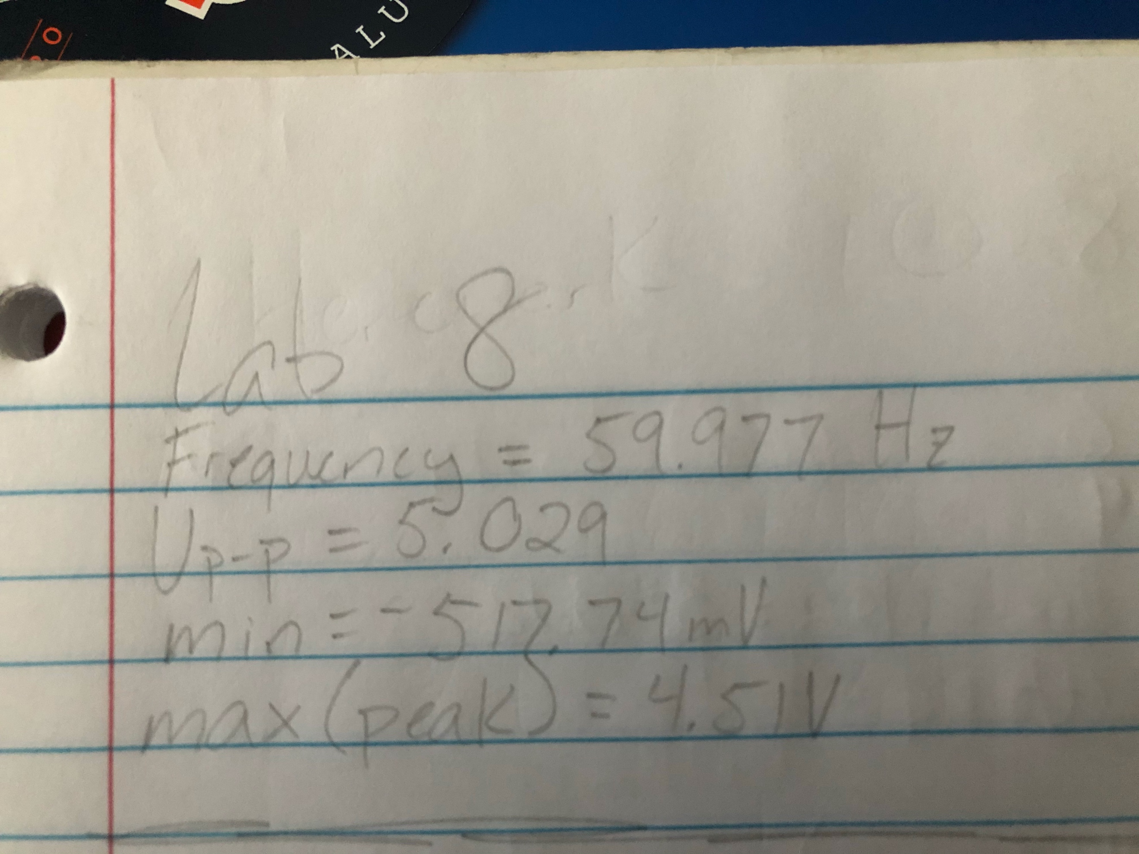

(1)

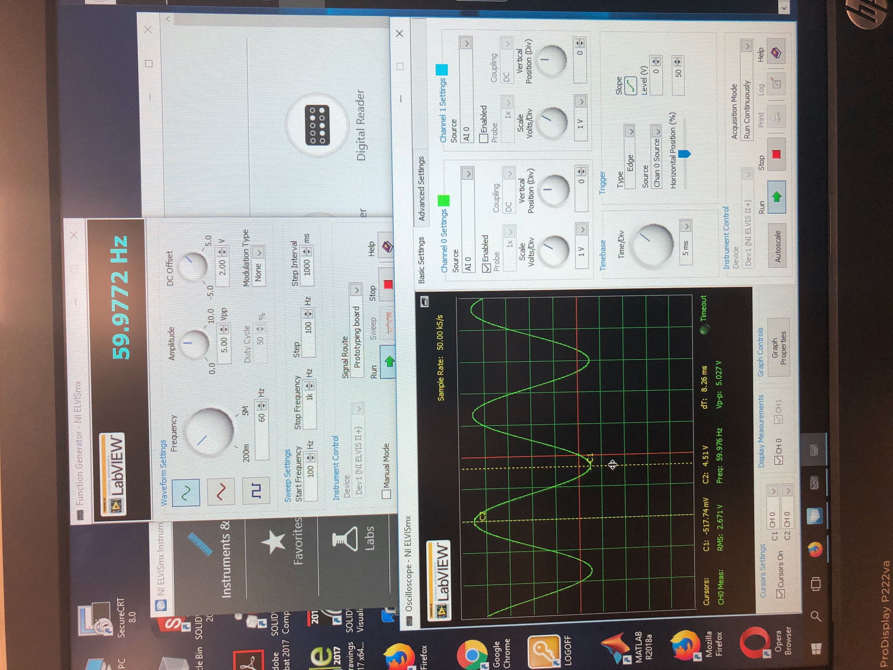

(2)

FGEN and OSCOPE measurements

Summary Table

|  |  |
| --- | --- |
| Frequency | 59.9772 Hz |
| Peak to Peak V | 5.029 V |
| MIN | -517.74 mV |
| MAX | 4.51 V |

Exercise 2&3 Questions

Exercise 2: Describe what happens as the trigger level is varied. Now change the trigger level to 4.7V. After several seconds, the measured signal should disappear, and nothing will be measured. Why?

Answer: The trigger level determines at what waveform the voltage sweep will start. When the trigger level is changed, and the signal disappears, it is because the trigger level has been told to sweep voltage at a level to high/low for the desired signal.

Exercise 3: What do the volts/div and Time/div knobs do?

Answer: These knobs do not affect the signal in any way but do change the scaling factor for fitting the signal to screen. The voltage/div knob controls the vertical scale, and the time/div knob controls the horizontal factor. These are used to fit the signal perfectly on screen for more precise measurements.

Exercise 4

Given the charging circuit, solve for k1, k2, k1+k2, and tau1 in terms of Vs, R1, R2, and C.

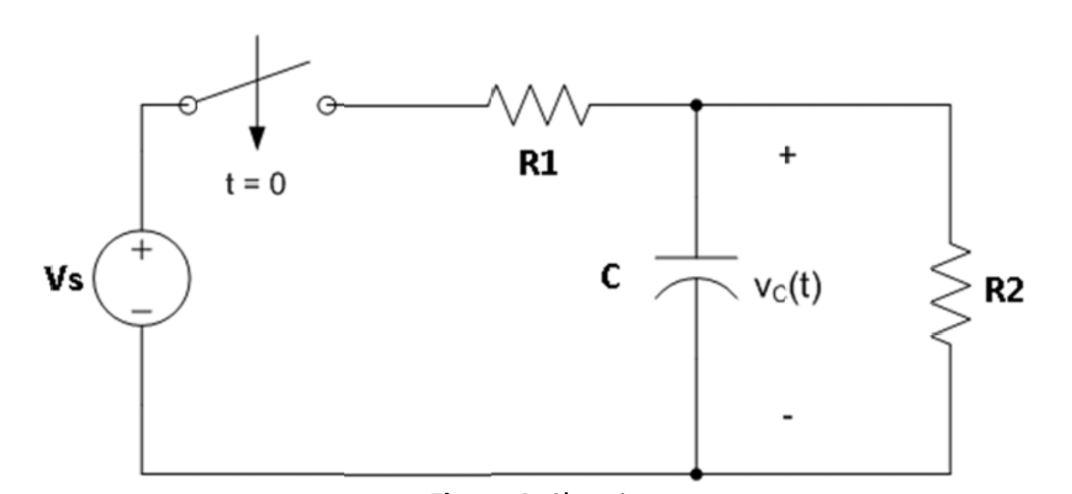

(3)

Circuit 1

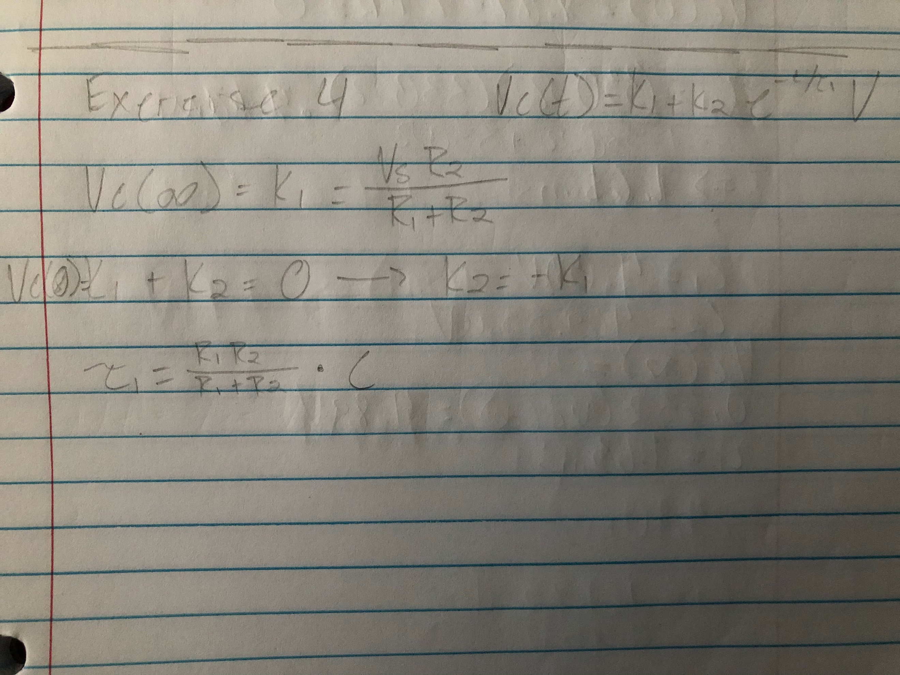

(4)

Summary Table

|  |  |
| --- | --- |
| K1 | (VsR2)/(R1+R2) |
| K2 | -K1 or -(VsR2)/(R1+R2) |
| K1+K2 | 0 |
| Tau1 | ((R1R2)/(R1+R2))*C |

Exercise 5

Given the discharging circuit, solve for k3, k4, k3+k4, and tau2 in terms of Vs, R1, R2, and C.

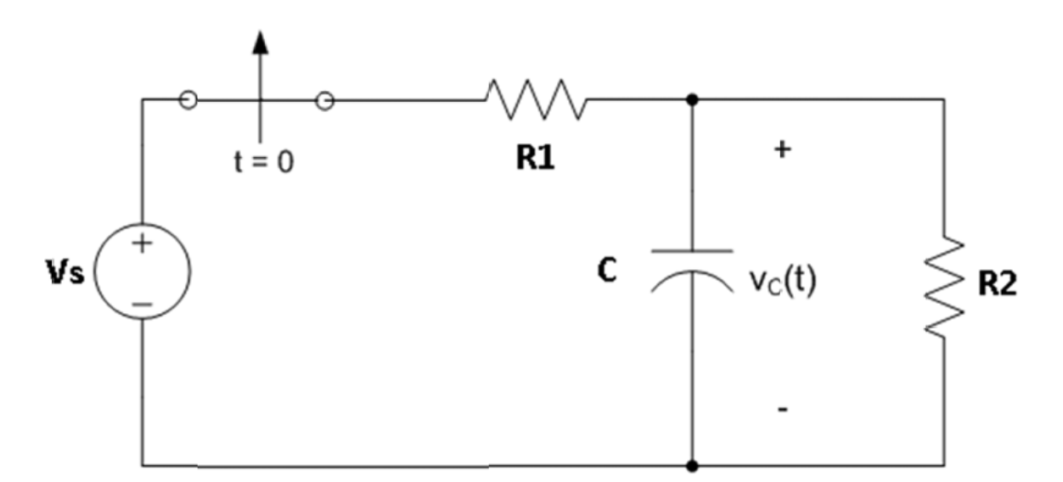

(5)

Circuit 2

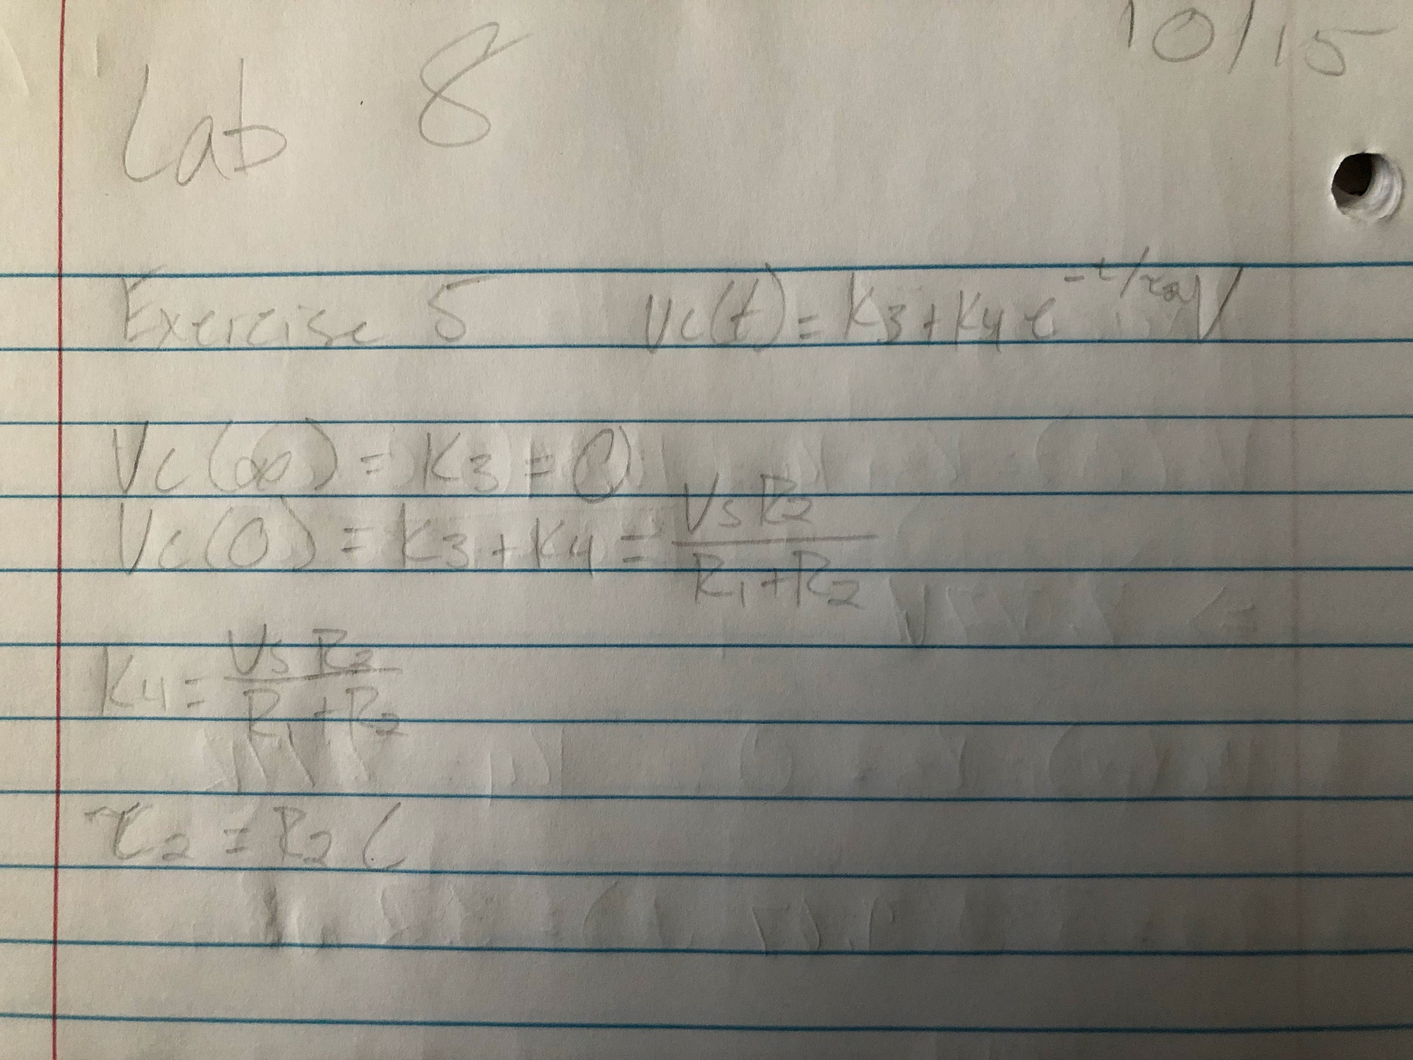

(6)

Summary Table

|  |  |
| --- | --- |
| K3 | 0 |
| K4 | (VsR2)/(R1+R2) |
| K3+K4 | (VsR2)/(R1+R2) |
| Tau2 | R2*C |

Exercise 6

Construct the capacitor charging circuit 1 using:

Vs = 15.5V

R1 = 330 Ohm

R2 = 330 Ohm

C = 10uF

And calculate Vc(0), Vc(infinity), time constant(tau).

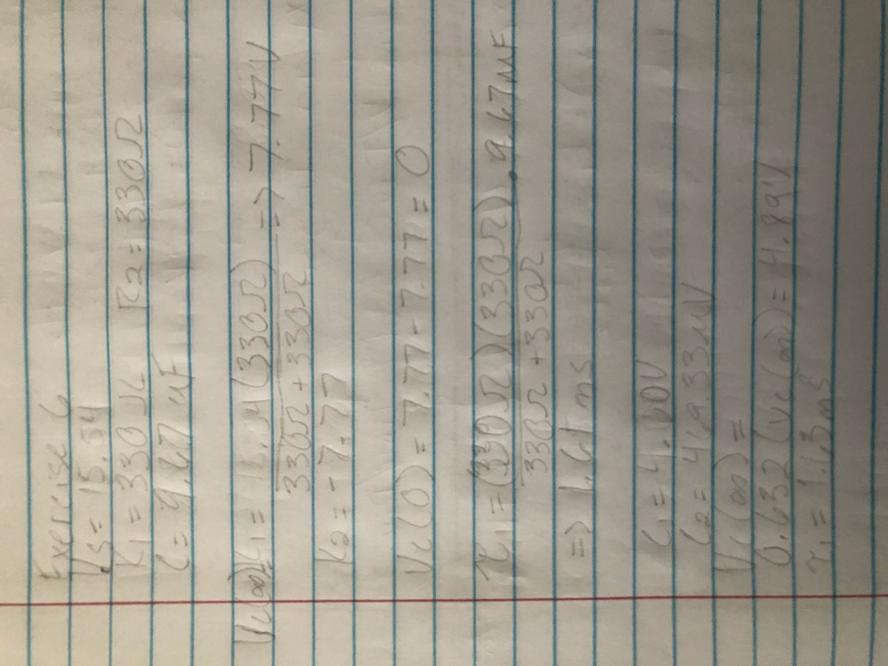

(7)

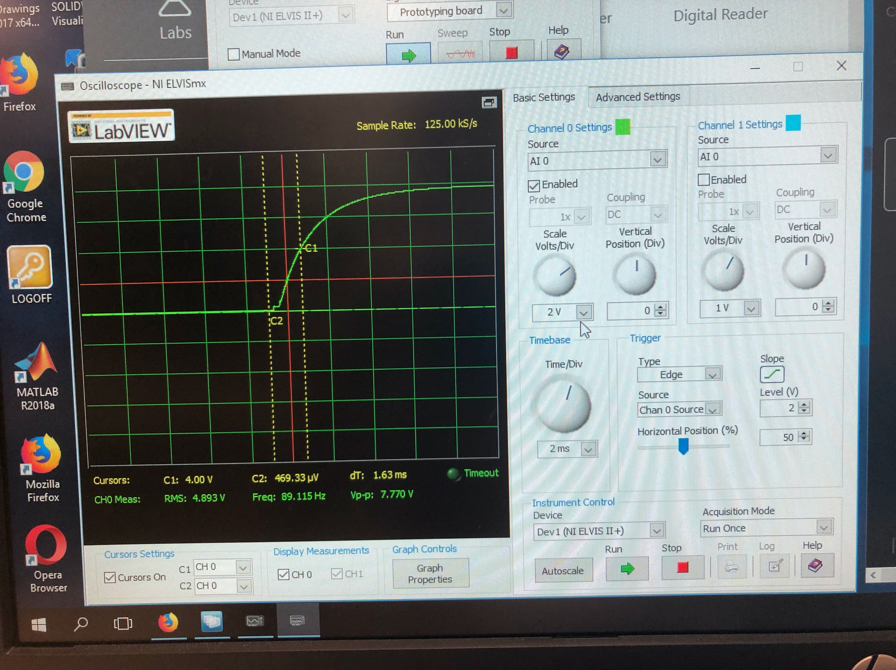

(8)

Oscope front panel

Summary Table

|  |  |
| --- | --- |
| Vc(0) = K1+K2 | 0 |
| Vc(infinity) = K1 | 7.77 V |
| Tau | 1.63ms |

Exercise 7

Construct the capacitor discharging circuit 2 using:

Vs = 15.5V

R1 = 330 Ohm

R2 = 330 Ohm

C = 10uF

And calculate Vc(0), Vc(infinity), time constant(tau).

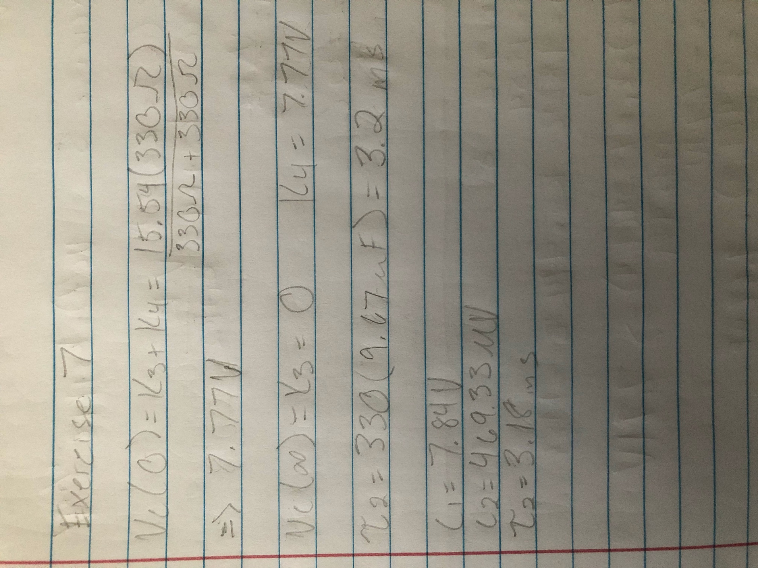

(9)

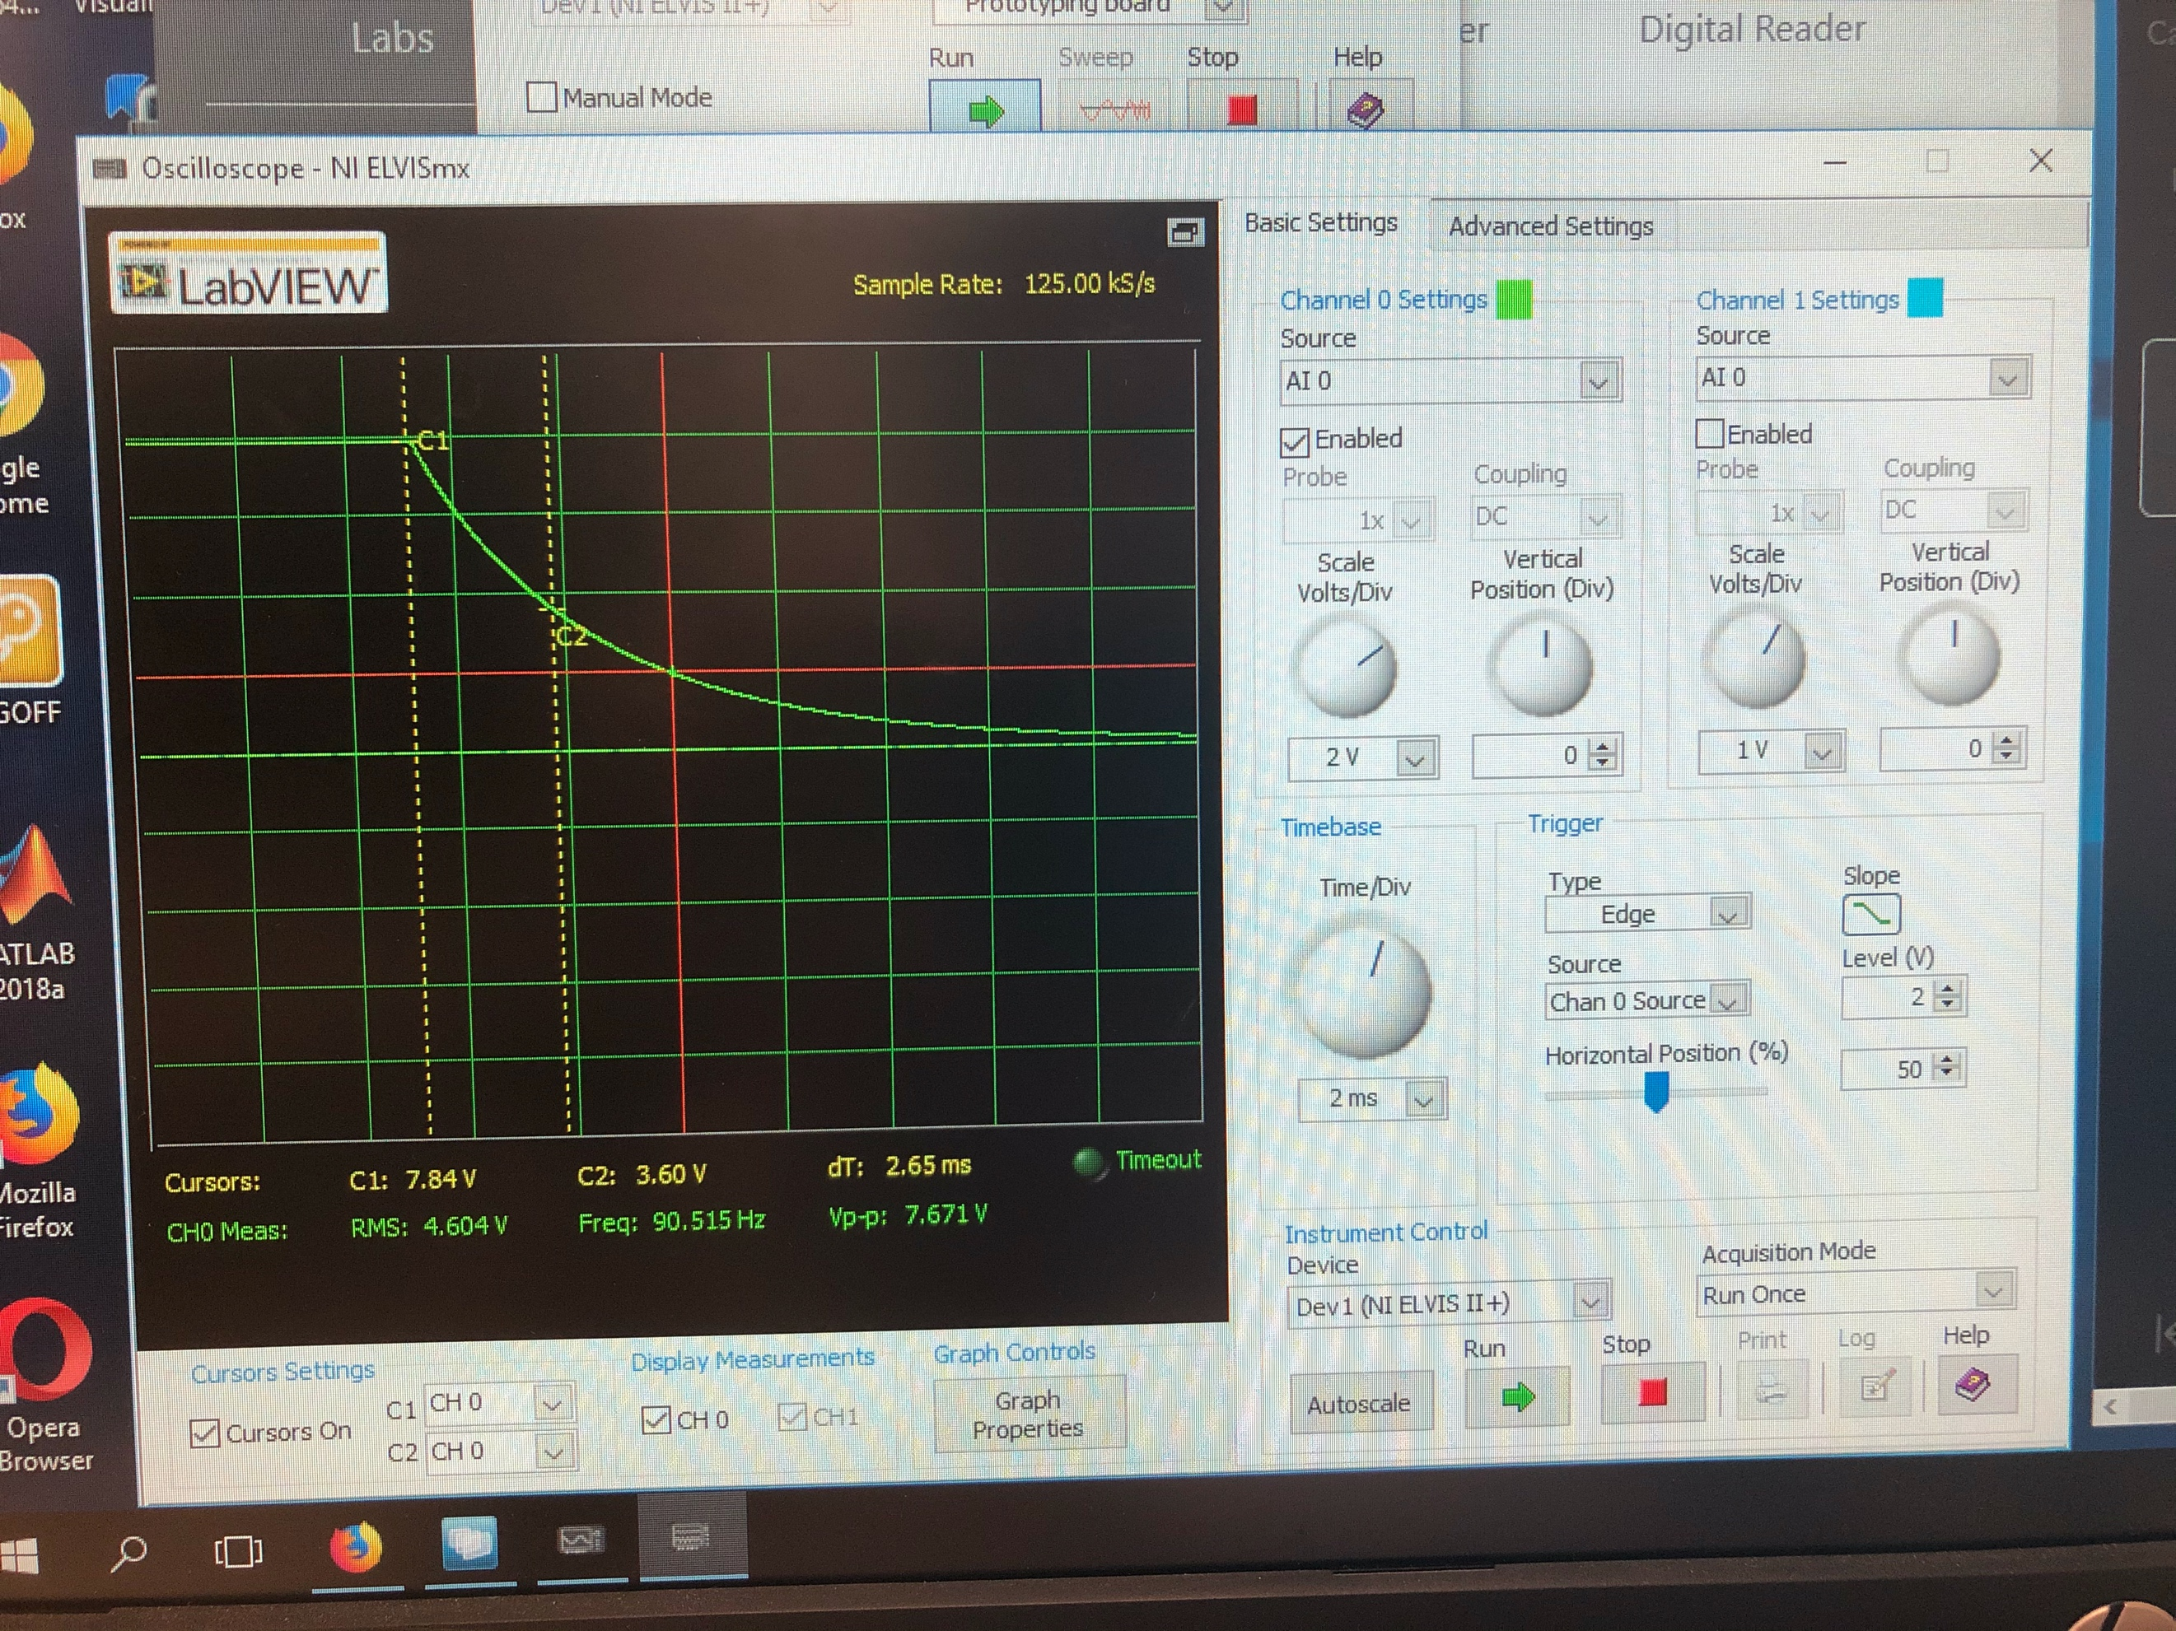

Oscope front panel (10)

Summary Table

|  |  |
| --- | --- |
| Vc(0) = K3+K4 | 7.77 V |
| Vc(infinity) = K3 | 0 |
| Tau | 3.18ms |

Exercise 8

Repeat exercises 6&7 using:

Vs = 15.5V

R1 = 1k Ohm

R2 = 1k Ohm

C = 10uF

Exercise 6

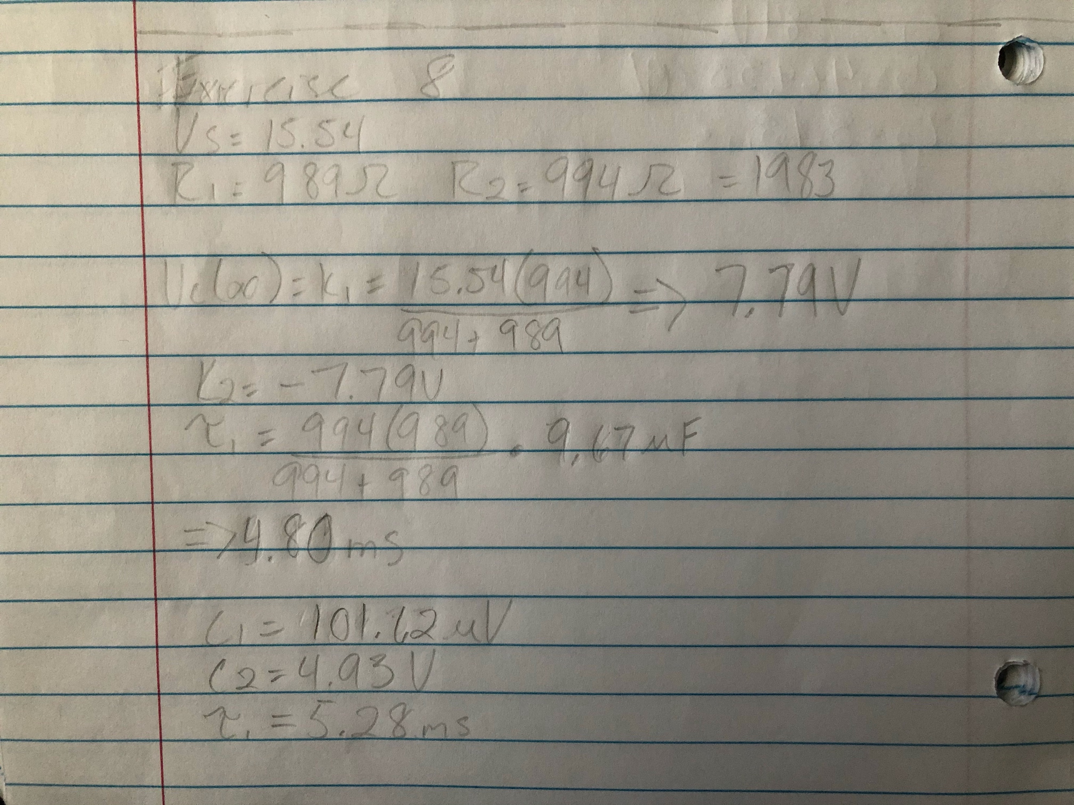

(11)

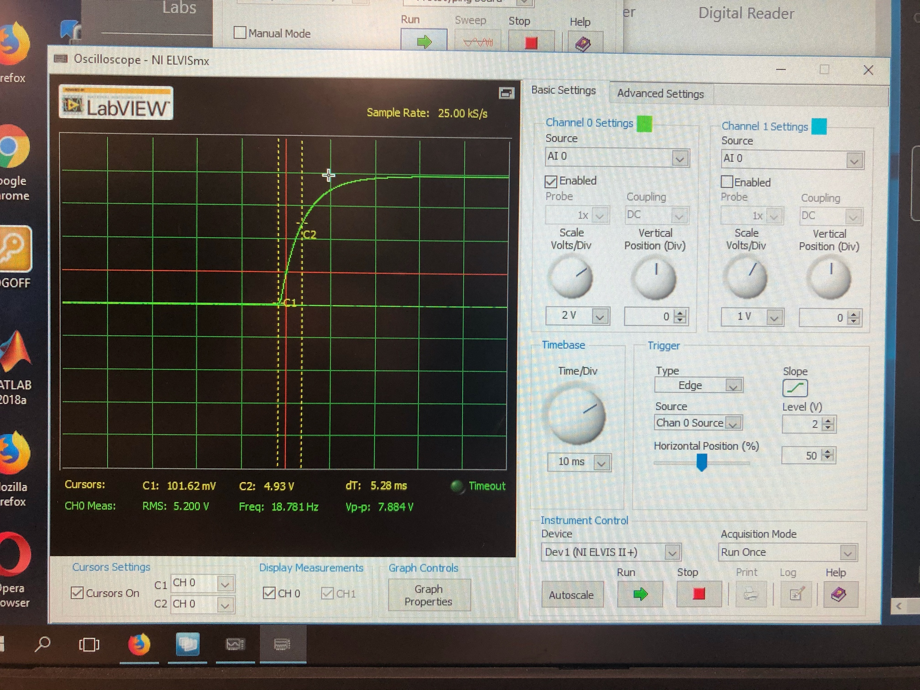

(12)

Oscope front panel

Summary Table

|  |  |
| --- | --- |
| Vc(0) = K1+K2 | 0 |
| Vc(infinity) = K1 | 7.79 V |
| Tau | 5.28ms |

Exercise 7

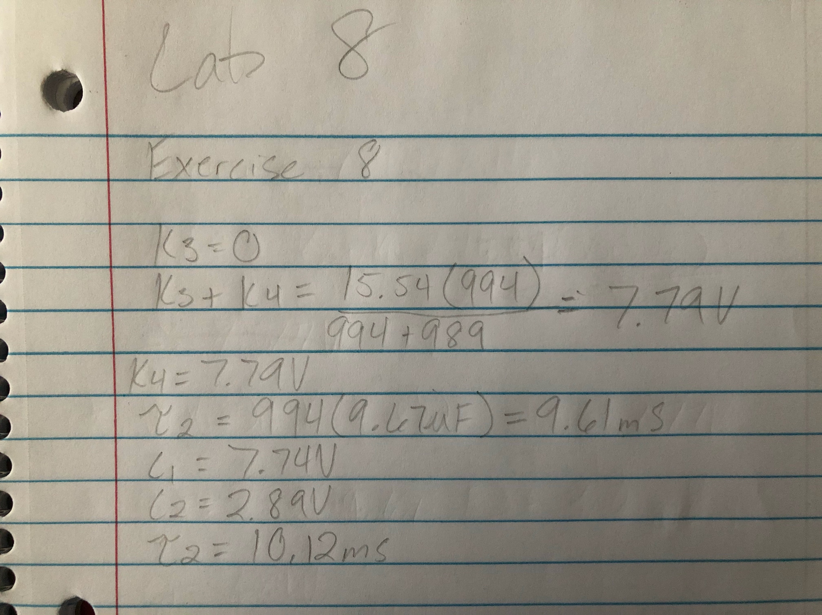

(13)

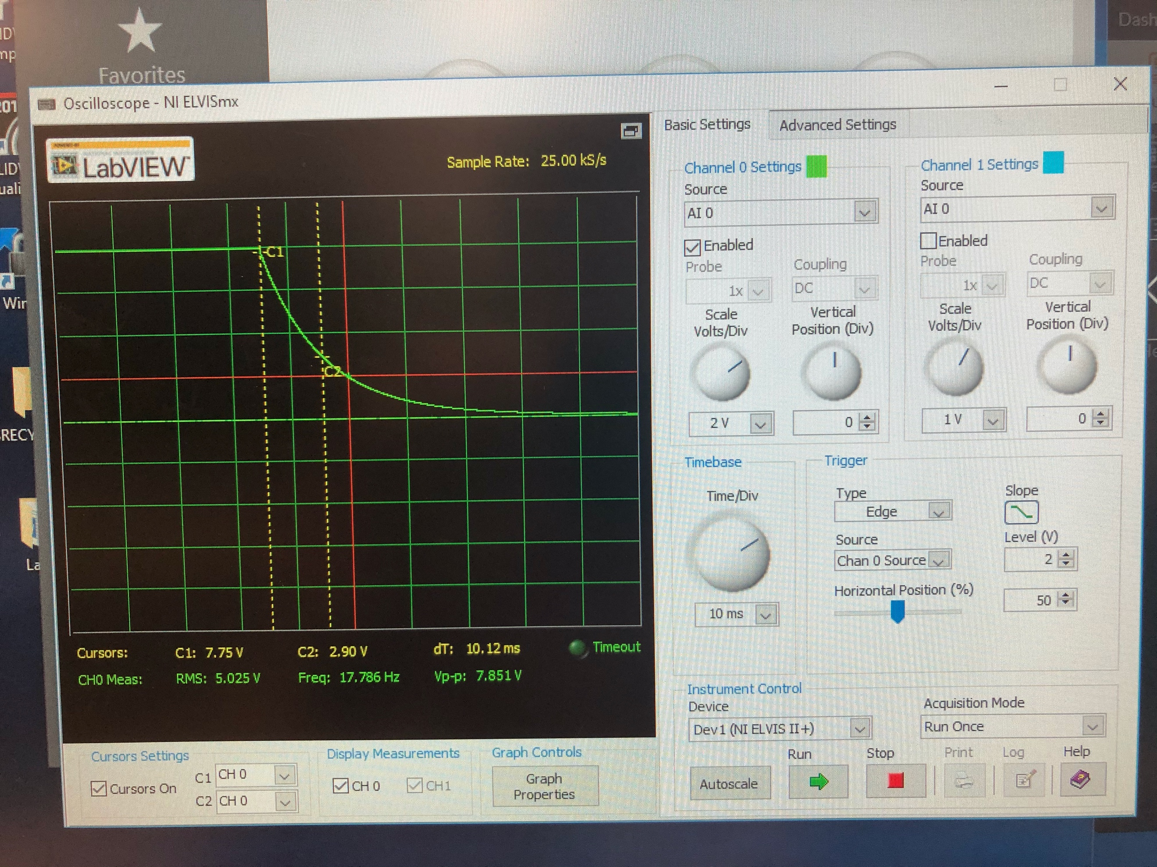

(14)

Oscope front panel

Summary Table

|  |  |
| --- | --- |
| Vc(0) = K3+K4 | 7.79 V |
| Vc(infinity) = K3 | 0 |
| Tau | 10.12ms |

Exercise 10

Table

|  |  |
| --- | --- |
| Vc(infinity) Exercise 6 | 7.77 V |
| Vc(infinity) Exercise 8 | 7.79 V |
| Tau1 Exercise 6 | 1.63ms |
| Tau1 Exercise 8 | 5.28ms |
| Tau2 Exercise 7 | 3.18ms |
| Tau2 Exercise 8 | 10.12ms |

Questions:

1. Compare the final voltage across the charging capacitor. Is one smaller, larger, or the same?

The voltages are the same, due to the fact that everything in the circuit is the same, except for the resistors, which does not change the overall voltage, only the time it takes to get that voltage.

1. Compare the charging time constant across the charging capacitor. Is one smaller, larger, or the same?

The time constant is slightly higher in exercise 8, since the resistors were changed to a higher resistance, it increases the amount of time it takes the circuit to get to maximum voltage, since the circuit is has to charge up the capacitor before getting to maximum voltage.

1. Compare the discharging time constant across the discharging capacitor. Is one smaller, larger, or the same?

The time constant is much higher in exercise 8, since the resistors were changed to a higher resistance, it increases the amount of time it takes the circuit to get to maximum voltage, since the circuit has to constantly discharge the capacitor, while trying to raise to maximum voltage.

Conclusion

This lab is very helpful for getting students ready to use an Oscope, a tool critical for helping Electrical Engineers study electric signals. This lab also helps with showing students how to calculate transient circuits, then construct the circuit and test for the same results.

Bibliography

1. Hand-written equations for exercise 1
2. FGEN and Oscope measurements for exercise 1
3. Circuit 1 given for exercise 4
4. Hand-written equations for exercise 4
5. Circuit 2 given for exercise 5
6. Hand-written equations for exercise 5
7. Hand-written equations for exercise 6
8. Oscope measurements and front panel for exercise 6
9. Hand-written equations for exercise 7
10. Oscope measurements and front panel for exercise 7
11. Hand-written equations for exercise 8 part 1
12. Oscope measurements and front panel for exercise 8 part 1
13. Hand-written equations for exercise 8 part 2
14. Oscope measurements and front panel for exercise 8 part 2